Estime’s Café Monthly Local Seo Report

1. Business Results
August directions on GBP: 406 DIRECTIONS REQUESTS
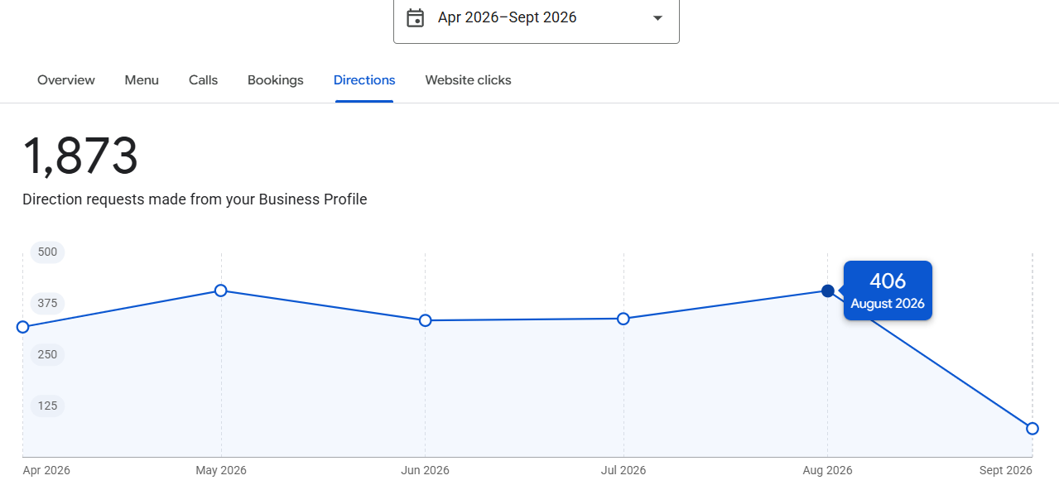

August calls on GBP: 129 CALLS
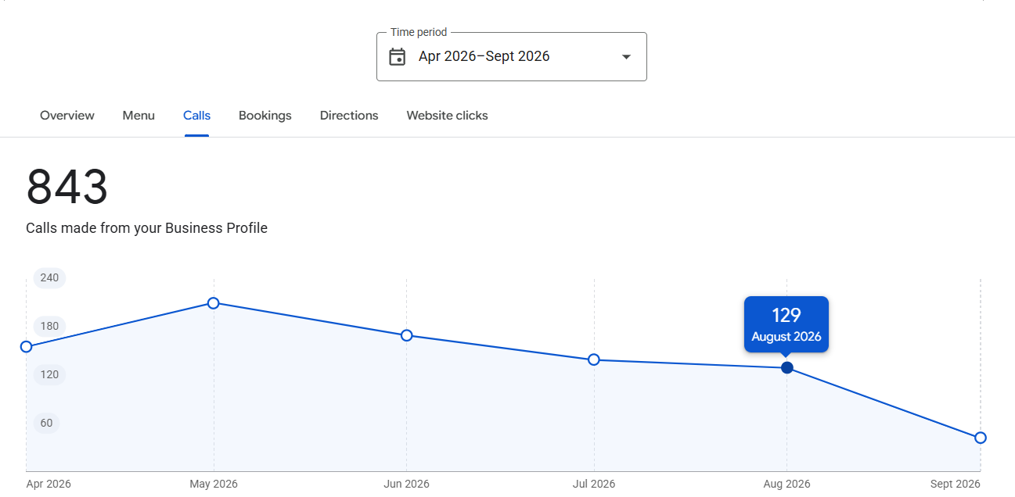

AUGUST WEBSITE CLICKS: 407
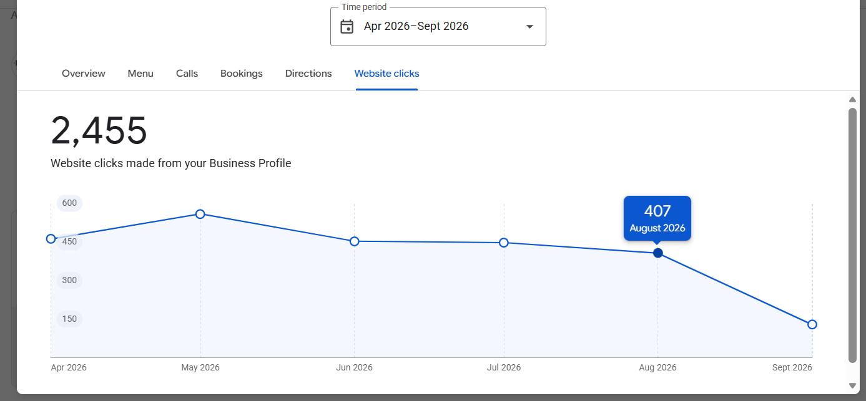

2. Visibility
Lunch near me
3 weeks comparison show a great improvement 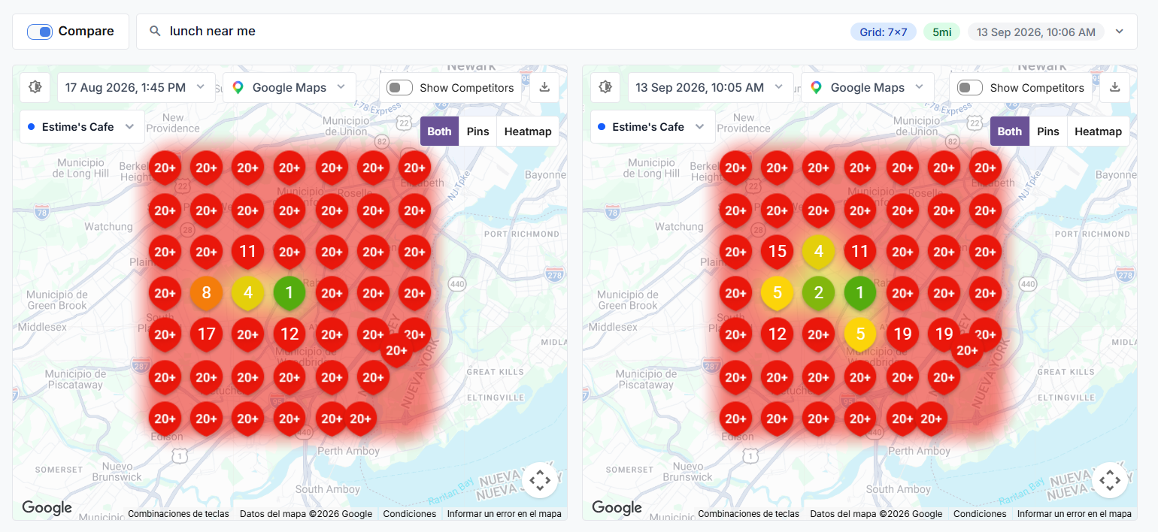

Breakfast near me: Also improvement on the positions
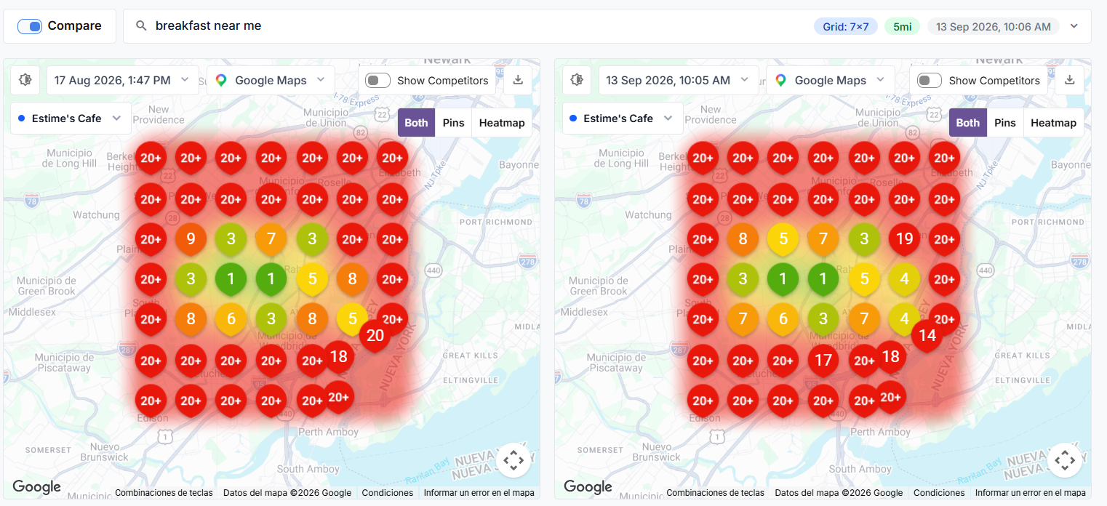

Brunch near me: also great improvement.
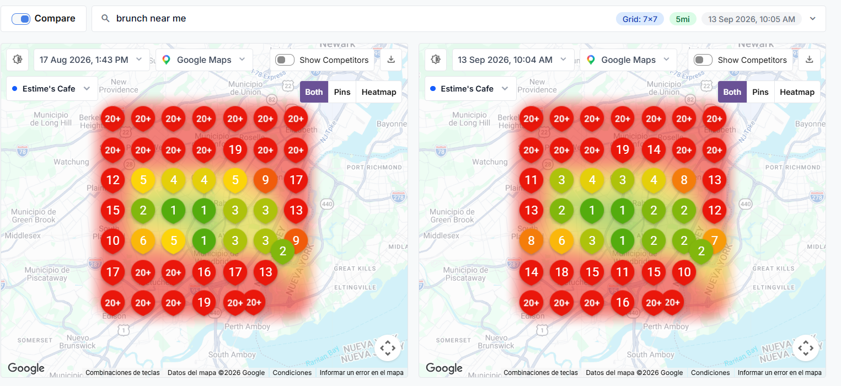

Organic clicks/traffic
No organic clicks/traffic because the new website is not up because you haven't authorized it yet.

3. Work Completed
Status Notice:
- Website Status (100% Complete & Ready to Launch): The new website for Estime’s Café is built, tested, and packaged into a deployment bundle (hostinger-static.zip). The site is currently offline awaiting owner authorization to publish.
- Impact on Google Business Profile (GBP): Because the site is not yet published, direct landing page links for specific services, menus, and catering packages cannot be added to Google Maps yet.

1. Web Development & Conversion Features (Pending Owner Authorization)
- New Next.js Web Platform
Rebuilt the website on Next.js to provide a fast, responsive mobile and desktop experience. The layout puts online ordering, phone calls, and catering inquiries front and center.
- Interactive Digital Menu (/menu)
Programmed the full menu directly into web code instead of using static PDF files. Covers breakfasts, pancakes, sandwiches, steak, seafood, keto items, and beverages, allowing customers to view items instantly on mobile devices while letting search engines read prices and items.
- 8 Core Pages
Built targeted pages for Home, Menu, Catering, Private Events, Order Online, About Chef Duke, Reviews, and Contact. This gives distinct entry points for everyday diners, private event bookings, and corporate catering clients.
- Automated Catering Quote System (/api/catering-leads)
Created a dedicated catering inquiry form with backend email handling via Resend. Quote requests route directly to the restaurant's inbox.
- Sticky Mobile Action Bar
Added a fixed action bar at the bottom of mobile screens with direct buttons for calling the restaurant, viewing the menu, and requesting catering quotes.
- Image Optimization & Asset Delivery
Converted dish photography to WebP/AVIF image formats with native lazy-loading and fixed aspect ratios. Reduces page payload and prevents layout shifts (CLS = 0) on mobile connections.

2. Google Business Profile & Local Maps
- Updated the profile title to include primary search terms (Estime's Café — Breakfast, Brunch & Lunch), matching local search intent for breakfast, brunch, and lunch in Colonia and Woodbridge Township.
- Set Brunch Restaurant as the primary business category, supported by 6 secondary categories: Breakfast Restaurant, Catering Food and Drink Supplier, Haitian Restaurant, American Restaurant, Cafe, and Event Venue. This covers all revenue streams from daily breakfast to corporate catering.
- Wrote a complete, keyword-rich 750-character business description highlighting the restaurant’s 8-year local history on Inman Ave, Chef Duke Estime's fusion cuisine, dine-in brunch, and office catering offerings.
- Filled in all missing GBP profile fields: operating hours, primary phone, exact address, delivery/takeout flags, wheelchair accessibility, payment methods, and dining attributes.
- 23 Service Listings Added to GBP
Wrote and configured 23 service entries with descriptions, prices, and keywords under Brunch Restaurant, Breakfast Restaurant, Catering Food and Drink Supplier, and Haitian Restaurant categories. Direct web links will be added once the site goes live.
- NAP & Geolocation Standardizing
Aligned the business name, address (238 Inman Ave, Colonia, NJ 07067), phone number (732-669-7581), and precise GPS coordinates across site code and business profile settings.

3. SEO Strategy & Technical Code Audit
- Local Keyword Mapping
Mapped local search terms for Colonia, Woodbridge, and Edison focusing on high-intent terms like breakfast pancakes and corporate catering to drive targeted traffic.
- Structured Data Markup (JSON-LD)
Implemented Schema.org data (Restaurant, LocalBusiness, PostalAddress, Offer, FAQPage) so search engines can extract hours, location, prices, and menu details.
- Technical Audit & Crawl Cleanup
Audited the codebase resolved route redirect loops, configured robots.ts, and generated an XML sitemap (sitemap.ts) to ensure clean indexation upon launch.

4. Search Engine & Content Strategy
- 6-Month Content Roadmap
Designed a 6-month content schedule focused on Chef Duke's culinary background and Creole-American fusion dishes to build search authority in Central Jersey.
- Structured FAQ Data for AI Search (GEO)
Formatted menu details, dietary options, and catering FAQs into structured tables to improve visibility in AI search features (ChatGPT, Perplexity, Google AI Overviews).
- Production Build Deployment Package
Compiled and exported the production static build archive, verified and ready to upload to Hostinger as soon as authorization is granted.

4. What Changed / What We Learned

What Changed:
- Stronger Local Map Pack Visibility: Optimizing the Google Business Profile title, categories, business attributes, and 23 services led to measurable local growth—generating 406 direction requests, 129 direct phone calls, and 407 clicks in August.
- Local Keyword Rank Improvements: Search rankings for "lunch near me", "breakfast near me", and "brunch near me" showed steady week-over-week rank gains across Colonia and Woodbridge Township.
- Complete Digital Infrastructure Ready: The website architecture, digital HTML menu, JSON-LD schemas, and B2B catering quote system are 100% built, tested, and packaged for immediate deployment.

What We Learned:
- Local Map Packs Have a Ceiling Without a Web Domain: While GBP optimizations successfully drive calls and directions, GBP alone cannot capture high-ticket B2B catering orders or non-map organic search traffic.
- Zero Organic Traffic Loss: 100% of organic website traffic is currently nor measured because the new site remains offline awaiting client authorization.
- Third-Party Platform Synergies: Integrating DoorDash and UberEats credentials with the new site's ordering funnel is essential to standardize pricing, menu items, and attribution across all digital channels.

Strategic Takeaway:
Publishing the website will immediately bridge local map visibility with organic search traffic, allowing us to link GBP services directly to dedicated web pages and start capturing corporate catering leads across Middlesex County.

5. Next Month Priorities

- Add formspree once website is up
- Upload images to gbp menu
- Configure search console
- Define realistic service area / customer travel radius
- Identify priority cities / neighborhoods and realistic local reach
- Identify trust / proof elements needed
- Give credentials access to door dash account and uber eat account.
- Launch Website
- DOORDASH AND UBEAR EAT ATRIBUTION AND ANALYTYCS CONFIG
- Create/verify Ubersuggest project for the site
- Track approximately 10–20 primary keywords (not the full keyword universe)
- Configure/verify primary conversion tracking
- Configure source attribution / UTMs where applicable
- Verify website vs GBP attribution where possible
- Competitor + SERP research
- Citation review
- Authority / backlink review where relevant
- Conversion tracking review
- Verify/create XML sitemap
- Submit/verify XML sitemap in Google Search Console
- Verify NAP consistency
- Audit/repair priority directories and citations
- Review/fix Yelp
- Claim/verify Apple Business Connect / Apple Maps when applicable
- Upload real, current photos
- Upload useful videos / 360 content when appropriate
- Establish review-response process
- Establish GBP posting process

Needed from Client

Publish the website. Publishing the site enables Google to index the pages and allows direct website links to be attached to the Google Business Profile.
Give credentials access to door dash account and uber eat account.

